Developing a Marketing Strategy for AstraZeneca
[Name of Student]
[Name of Institute]
[Date]

Table of Contents
1 Executive Summary 3
2 Introduction 3
3 Literature Review 5
3.1 STP marketing segmentation, targeting, and positioning 5
3.2 SWOT and Ansoff Matrix 5
3.2.1 Keller's Brand Equity Model 6
4 Background Analysis 6
4.1 Local, National and Regional Context of Marketing Approaches 6
4.2 Possible International Entry Methods- Identification and Evaluation 7
4.2.1 Strategic Alliance 7
4.2.2 Mergers and Acquisition (M&A) 7
4.2.3 Fully Owned Subsidiaries 8
4.3 The Influence of the Changing Business Environment on the Marketing Priorities and Marketing Management Functions 8
5 Application of Learning to Practice 10
Marketing Strategies 10
5.1 The Role of Marketing Theories and Principles in the selection of International Market and in developing an Entry Strategy 10
5.1.1 Evaluation of SWOT and Ansoff Matrix 10
5.1.2 Comparison and Contrast 10
5.2 SWOT Analysis 11
5.2.1 Strengths 11
5.2.2 Weaknesses 11
5.2.3 Opportunities 11
5.2.4 Threats 12
5.3 Ansoff Matrix 12
5.3.1 Market Penetration 13
5.3.2 Market Development 13
5.3.3 Product Development 13
5.3.4 Diversification 13
5.4 Suitable Market Entry Strategy or Criteria- Strategic Alliance 14
Brand Management 15
5.5 Keller Brand Equity Model 15
5.5.1 Overview of Model 15
5.6 Application to AstraZeneca 15
5.7 Psychological and Sociological Factors Influencing Consumer Decision Making 17
5.7.1 Psychological Factors 17
5.7.2 Sociological Factors 18
5.8 Branding Strategy for AstraZeneca 19
5.8.1 Predicted Responses and Conversion Rate 19
New Product Development 20
5.9 Evaluation of Strengths and Weaknesses in Product Development 20
5.9.1 Strengths 20
5.9.2 Weaknesses 20
5.10 International Marketing Strategy for Expansion 21
5.10.1 Global Branding and Positioning 21
5.10.2 Localised Marketing and Customisation 21
5.10.3 Strategic Alliances 21
5.10.4 Advanced Digital Marketing and Data Analytics 21
5.11 International Marketing Plan for Diprifusor’s Automated Drug Identification System 22
6 Conclusion and Recommendations 24
6.1 Recommendations 24
References 26

Executive Summary
This marketing report emphasised over SWOT and Ansoff Matrix for AstraZeneca's international market selection and entrance as SWOT considered internal and external aspects, while the Ansoff Matrix suggested growth strategies. The report affirmed that strong R&D and a large pharmacological portfolio are AstraZeneca's strengths but supply chain risks and patent lawsuits remained as challenges under which strategic collaborations, especially in emerging economies the organisation would use local expertise and reduce risks for global expansion. Additionally the Keller's Brand Equity Model stressed on brand salience, performance and resonance which displayed that consumer participation and brand equity required addressing psychological and social elements including perceived risk and cultural norms. Furthermore, AstraZeneca's cooperation network and quality control help create new products, but supply chain complexity is a concern therefore to increase market penetration, the international marketing strategy emphasised over global branding, localised marketing, strategic partnerships, and advanced digital marketing. The report collectively established that R&D, global presence and diverse pharmaceutical portfolio are AstraZeneca's strengths but poor supply chain management, product discontinuations and patent litigations are weaknesses however rising healthcare demand in emerging regions provided opportunities for international market expansions

Introduction
The Cambridge Biomedical Campus houses AstraZeneca plc, a renowned British-Swedish multinational pharmaceutical and biotechnology corporation. AstraZeneca, a multinational pharmaceutical giant that was founded in 1999 when Swedish Astra AB and British Zeneca Group merged soon after that, it has the greatest UK market capitalization of 231 Billion Dollars demonstrating its market dominance with financial strength. The size of the organisation is displayed by its growth, as the revenue at AstraZeneca grown significantly year-over-year under which the company's sales rose 16.55% to $12.679 billion in the quarter ended March 31, 2024. Previously the revenue was $45.811 billion in 2023; up 3.29% from 2022 and 18.53% from 2021 hence this increasing trend illustrated AstraZeneca's market penetration and growth in size of the organisation (Figure 01). On the other hand, R&D spending of $6-9 billion yearly derived AstraZeneca's growth as the company's UK, Sweden and US R&D centres provided a pipeline of novel medications while strategic acquisitions like Cambridge Antibody Technology and Spirogen also enhanced its R&D and market reach (Macrotrends.net, 2024).
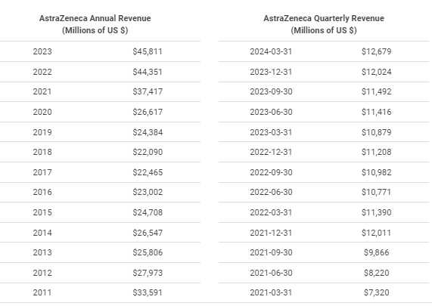
Figure 01: Quaterly and Annual Revenue Growth by AstraZeneca plc (Macrotrends.net, 2024)
Furthermore AstraZeneca operated internationally with products in over 60 countries while the company's broad global reach and wide product line allowed it to meet regional healthcare demands (Macrotrends.net, 2024). Additionally as of 2023 its 83,500 people supported its enormous activities and commitment to offer life-changing medications (AstraZeneca, 2024). Along with that in the domain of product offering oncology, cardiovascular, gastrointestinal, infection, neurology, respiratory and inflammation are among AstraZeneca's many therapeutic areas while the recent branding included the Oxford–AstraZeneca COVID-19 vaccine Vaxzevria however the company modified the Conditional Marketing Authorisation product information for the AstraZeneca COVID-19 vaccine to “Vaxzevria” (M, 2020). Collectively the AstraZeneca's global presence, strategic focus on innovation and large R&D spending provided them a pharmaceutical industry edge as the company's sustained financial growth and crucial involvement in tackling serious health issues like the COVID-19 pandemic demonstrated its worldwide healthcare relevance thus AstraZeneca is well-positioned to grow and innovate to address global patient requirements.
This marketing report will analyse multiple marketing ideas and methods for AstraZeneca's international market selection and entrance in the global marketplace.

Literature Review
In order to negotiate varied regulatory environments, cultural differences and competitive dynamics, the pharmaceutical industry's international marketing environment is very complicated and calls for a combination of strategic frameworks and cutting-edge tactics. This literature review explored modern marketing concepts and theories in international pharmaceutical marketing, focusing on market access, brand equity and strategic partnerships.

STP marketing segmentation, targeting, and positioning
Market segmentation, targeting, and positioning (STP) referred as key to choosing international markets and creating entrance strategies because STP helped organisations prioritising markets based on demand, competition and regulation. In compliance to customise pharmaceutical marketing techniques, demographic, psychographic and behavioural data are analysed under which AstraZeneca's personalised healthcare solutions in growing countries like China and India demonstrated the importance of STP in aligning product offers with local market demands and preferences (Verma, 2024).

SWOT and Ansoff Matrix
SWOT and the Ansoff Matrix are crucial for strategic planning and market penetration as SWOT analysis provide a holistic perspective of strategic positioning by assessing internal and external strengths, weaknesses, opportunities and threats therefore SWOT is useful in first market evaluation despite its simplicity. In contrast, the Ansoff Matrix aligned with strategic alternatives with growth goals through market penetration, market expansion, product development, and diversification (Lin, Xiaoyu and Jianqiang, 2023). In this manner the Liu (2020) revealed that Ansoff Matrix was used to expand AstraZeneca's market and product portfolio via strategic collaborations and therapeutic diversification, such as the acquisition of Alexion Pharmaceuticals.

Keller's Brand Equity Model
Pharmaceutical competitiveness depended on brand equity under which Keller's CBBE Model is a systematic method to developing, assessing and maintaining brand equity, emphasising identity and resonance (Raut et al., 2019) hence, strategic brand management builds customer trust and long-term competitive benefits.
Collectively it is affirmed that by combining STP SWOT analysis, Ansoff Matrix, and Keller's Brand Equity Model, pharmaceutical marketers can navigate the international marketing environment. These marketing ideas helped organisations like AstraZeneca to choose markets, create entry strategies, build brand equity and gain a competitive edge followed by growth and strategic innovation in the global pharmaceutical industry.

Background Analysis

Local, National and Regional Context of Marketing Approaches
AstraZeneca possessed a complex, multi-faceted marketing strategy to reach varied local, national and regional audiences as the Brilinta, Diabetes, Oncology, Respiratory, and Cardiovascular are the company's marketing priorities (Team TBH, 2024). In compliance to this AstraZeneca made its advertising relevant and effective by targeting healthcare professionals, patients and carers. Locally, AstraZeneca tailored its marketing to local cultures and regulations as this involves local advertising laws and cultural awareness under which the in the campaigns like “Your Heart Matters” (2010) and “Breathe Better” (2012), AstraZeneca utilised local media to reach and engage communities around health problems (Reporter, 2023). On the other hand AstraZeneca adopted conventional and digital media to generate national coverage and engagement under which the organisation reached a large audience via television, radio and print media. Similarly the social media email and search engine marketing enable focused and interactive involvement while the videos, infographics, and interactive information are used in campaigns to engage and motivate hence this multi-channel strategy provided broad coverage and audience interaction (PEX Network, 2023). Along with that, AstraZeneca markets to demographic and epidemiological changes regionally under which the regional advertisements focused on diseases that is common in particular locations like Asthma in Malaysia (Reporter, 2023), adapting messaging to highlight their relevance and advantages however the collaborations with regional healthcare providers and organisations elevated campaign credibility and reach. AstraZeneca's marketing approaches relied on partnerships and collaborations as AstraZeneca collaborates with Daiichi Sankyo, Merck and Oxford to access cutting-edge science and innovate (Daiichisankyo.com, 2019). In this manner marketing approaches by AstraZeneca's are relevant, engaging and effective across markets because they are adapted to local, national and regional contexts therefore their innovative media use and solid collaborations allowed them reach broad audiences and promote life-changing treatments.

Possible International Entry Methods- Identification and Evaluation
As a worldwide pharmaceutical company AstraZeneca opened to several alternatives for entering international markets that included Strategic partnerships, M&A, and wholly-owned subsidiaries are effective international entry methods;

Strategic Alliance
Strategic collaborations with local enterprises utilised capabilities and share resources under which AstraZeneca could form co-development, joint venture or marketing partnerships. The primary advantage of this entry strategy in terms of indicator is market access and local knowledge as the alliances would the company to access to local partners' market knowledge, distribution networks and regulatory experience (He, Ghobadian and Gallear, 2021). Similar to this Gilead Sciences launched in China alongside Fosun Pharma using Fosun's local knowledge to negotiate regulatory frameworks and increase market penetration (Gilead.com, 2017) while the AstraZeneca's partnership with Daiichi Sankyo for cancer medication research and commercialization illustrated the potential for strategic alliances to enhance market reach and R&D capabilities (Daiichisankyo.com, 2019).

Mergers and Acquisition (M&A)
M&A provide quick market access and frequently a strong infrastructure by purchasing or combining with target market enterprises and according to Torres et al. (2020) via operational improvements and supplier bargaining leverage, M&A save considerable costs while the synergies elevated profits and competitiveness by increasing the product portfolio leading to economies of scale. In compliance to this Pfizer's acquisition of Hospira immediately enlarged its injectable medicines and biosimilars portfolio while the AstraZeneca's acquisition of Alexion Pharmaceuticals highlighted the advantages of M&A as this $39 billion purchase provided AstraZeneca access to Alexion's therapies and late-stage pipeline strengthening its immunology and rare illness market share ((Pfizer.com, 2015; Liu, 2020).

Fully Owned Subsidiaries
Wholly-owned subsidiaries required starting a new firm or buying an existing one in the target market to gain complete control and the indictor based advantages of this strategy included brand integrity and IP protection as owning the subsidiary helped in safeguarding brand integrity and IP (Cristina, 2020). Similarly strategy displayed a long-term commitment to the market as in China, Novo Nordisk utilised wholly-owned companies to maintain control and safeguard its patented diabetic therapies (Verma, 2024) hence this strategy would also help AstraZeneca to explore diverse therapeutic market with high standards and consistency.
Collectively the strategic alliances, M&A and wholly-owned subsidiaries benefited AstraZeneca's international expansion as the method selection relied on market conditions, strategic goals and control level therefore by using these strategies, AstraZeneca could expand globally, diversify its product line and develop sustainably.

The Influence of the Changing Business Environment on the Marketing Priorities and Marketing Management Functions
AstraZeneca's market priorities and management functions are greatly impacted by the continually evolving business environment as the technological advances, legislative changes, and customer expectations referred as the key influencing factors. Advanced technologies like digital health and big data analytics changed marketing techniques as the companies started valuing digital marketing, personalised communication and data-driven decision-making. On this account COVID-19 pandemic engagement by AstraZeneca with healthcare professionals and patients utilising digital technologies displayed the move towards virtual interactions and customised digital material (Astrazeneca.com, 2021). In addition to this stricter rules and compliance need more transparent and ethical marketing as the marketing management must verify that promotional operations conform to diverse local and international legislation. In line to this AstraZeneca's adaption to the EU's General Data Protection Regulation (GDPR) highlighted how regulations influenced marketing tactics, emphasising data protection and consent (Teodora, Popa and Sefora, 2018). On the other hand patient-centricity and corporate social responsibility are emerging consumer expectations thus customers want pharmaceutical businesses to be more transparent and engaged. Trust and community relations are increasingly marketing functions under which environmental and social impact initiatives by AstraZeneca illustrated how corporate ideals are being integrated into marketing (Figure 02) (‌Amri and Sami, 2022).
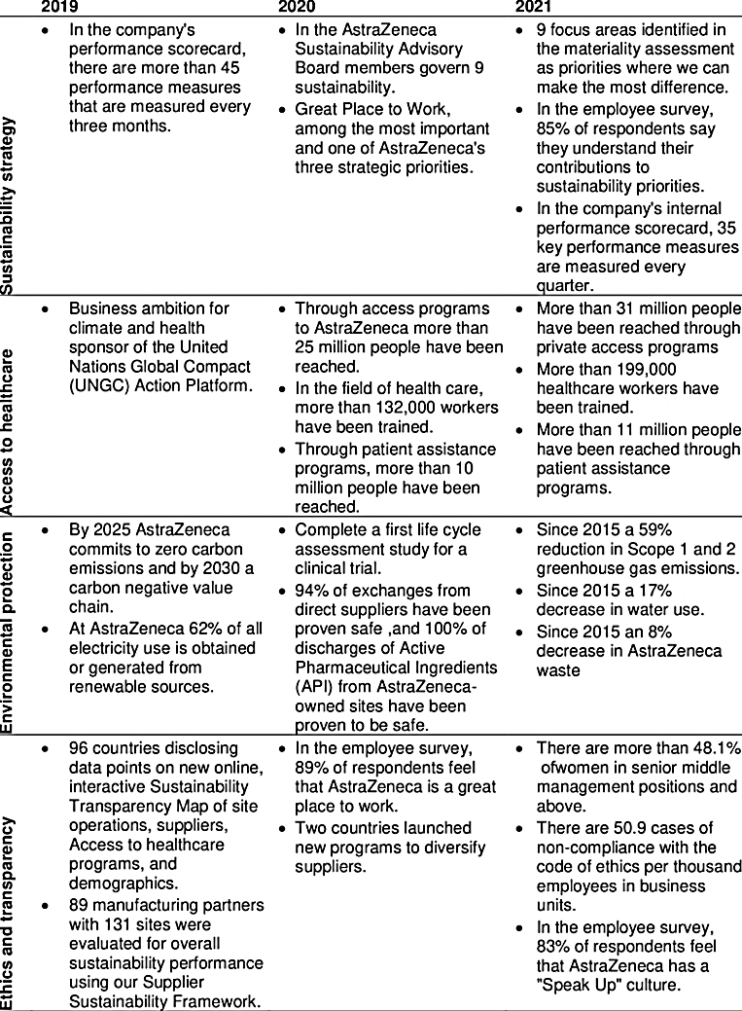
Figure 02: CSR Marketing Initiatives by AstraZeneca 2019-2021 (‌Amri and Sami, 2022)
Collectively during the COVID-19 pandemic, Moderna's marketing strategy had to adjust quickly to meet the increased demand for vaccinations and public scrutiny. Their transparent vaccine development and safety communication followed by successful use of digital platforms demonstrated the need for flexible marketing management in a changing business environment because this strategy acquired public trust and strengthened Moderna's global brand (Clifford, 2021). In this manner it is affirmed that ensuring compliance, encouraging trust and using technology to satisfy market expectations required adaptive marketing priorities and robust management functions in the pharmaceutical industry.

Application of Learning to Practice

Marketing Strategies

The Role of Marketing Theories and Principles in the selection of International Market and in developing an Entry Strategy
In choosing international markets and creating market entry strategies, marketing theories and principles are crucial because based on demand potential, competitive landscape, and regulatory environment, market segmentation; targeting and positioning (STP) the organisations identify and prioritise markets. Additionally the product maturity and market growth dynamics helped in determining the market entry time and type with theories like the Product Life Cycle (PLC) and BCG Matrix (Akter et al., 2021).

Evaluation of SWOT and Ansoff Matrix
SWOT is a complete internal and external analysis of strengths, weaknesses, opportunities, and threats as the strategic planning and risk assessment for foreign market entrance required this holistic view however, SWOT is simplistic and subjective therefore this tool lacked the depth needed for complicated market entrance choices (Lin, Xiaoyu and Jianqiang, 2023). On the other hand the Ansoff Matrix provided practical growth strategies (market penetration, development, product creation, and diversification) because it simplified foreign market entry decisions by linking strategic options to growth goals. Despite that the model's concentration on development strategies rather than market analysis neglected political, economic and cultural variables that are crucial for international expansion (Schlegelmilch, 2022).

Comparison and Contrast
SWOT provided a wide grasp of internal capabilities and external situations, making it more suitable for first market appraisal than other methods because it displayed the company's preparedness and new market dangers. However once a market has been chosen, the Ansoff Matrix is better suitable for strategic planning because it determined entry strategy that included market penetration joint ventures or product development collaborations (Schlegelmilch, 2022; Lin, Xiaoyu and Jianqiang, 2023. In compliance AstraZeneca could build a solid structure by merging both of these important tools because SWOT evaluates strengths and weaknesses against external opportunities and threats to find prospective markets while the Ansoff Matrix could be utilised to create market-specific entry strategies for international expansion, guaranteeing a complete and strategic approach.

SWOT Analysis
SWOT analysis evaluated an organisation's strengths, weaknesses, opportunities and threats as SWOT stands for these terms while SWOT analysis raised knowledge of the elements that influence decisions and strategies of the AstraZeneca;

Strengths
Strong operations and R&D skills are AstraZeneca's strengths because rapid decision-making and faster due diligence procedures elevated the market agility and responsiveness of the company. AstraZeneca capitalised on healthcare demand growth in emerging economies with a large commercial and R&D footprint as more than 60,000 individuals work for AstraZeneca in over 60 countries, giving it significant market penetration (AstraZeneca, 2024). Additionally R&D investment and a committed staff derived innovation at the organisation (Halbusi, Klobas and Ramayah, 2022) under which AstraZeneca's diversified pharmaceutical portfolio, comprising eleven medications with global sales over $45 billion encompassed cancer, cardiology and respiratory therapeutic areas, strengthening its market position.

Weaknesses
AstraZeneca possessed certain weaknesses as the drug shortages, like the Cefotan crisis, exposed supply chain management risks while the global performance and market stability suffered from product discontinuations. Similar to this AstraZeneca's image and financial obligations from patent and price litigation also damaged investor confidence and market perception (Ashp.org, 2016).

Opportunities
The demand of healthcare is rising in emerging nations followed by the investment opportunities; AstraZeneca could use its strong presence there to grow as AstraZeneca could extend its product portfolio with cost-effective bio-similars as the biosimilar industry grows. Collectively as the world population ageing, older persons require more medical interventions which aligned perfectly with the vast pharmaceutical range of AstraZeneca (Byttebier, 2022).

Threats
AstraZeneca confronted numerous threats as the expiry of patents for blockbuster medications like Seroquel would reduce market share and profits due to generic competition while the new product development is delayed and costlier due to strict medication development requirements (Liu, 2022). On this account maintaining market leadership and profitability is also difficult due to fierce rivalry from other pharmaceutical firms that create effective medications.
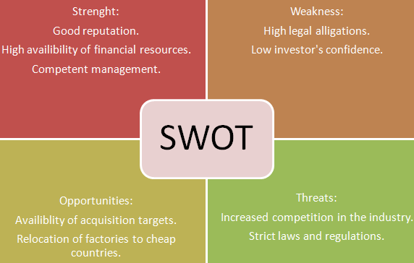
Figure 03: SWOT Analysis of AstraZeneca (Eric, 2018)
Collectively, the strong R&D investment and worldwide presence provided a solid platform for development to the company but resolving supply chain vulnerabilities, legal difficulties and competitive challenges is essential to maintaining its competitive edge and expansion to new markets in the dynamic pharmaceutical industry.

Ansoff Matrix
The strategic tool guide and facilitate corporate growth decisions as the Market development, market penetration, product diversification, and product development are the primary strategic choices in the Ansoff matrix while the strategic actions and choices made AstraZeneca successful globally under which the company adopted Ansoff matrix to dominate globally.

Market Penetration
AstraZeneca increased market penetration by increasing production capacity and investing extensively on marketing however the corporation can reach more clients in new markets with this technique (Zanjani et al., 2020). The company increased product appeal and accessibility by establishing competitive pricing and decreasing operating costs while optimisation of the company's distribution networks elevated market reach and efficiency. Similarly strategic collaborations and joint ventures like Daiichi Sankyo allowed AstraZeneca to reach broad client groups and increase market penetration.

Market Development
AstraZeneca targeted new client groups via regional and global expansion under which the research and development helped the corporation in adjusting its products to new markets therefore strategically entering growing markets like China and India displayed its worldwide expansion (Blablová, 2021).

Product Development
AstraZeneca adapted and introduced new products to satisfy changing healthcare demands as the innovative, high-quality medicines are introduced via strategic alliances and R&D funding (AstraZeneca, 2024).

Diversification
AstraZeneca acquired vertical and horizontal diversification via acquisitions and mergers because these approaches expand its product line and market share. AstraZeneca's acquisition of Alexion Pharmaceuticals elevated its immunology and rare illness expertise, displaying its diversification while this strategy reduced risk, increased income and enhanced worldwide competitiveness (Alexion Pharmaceuticals, Inc., 2023).
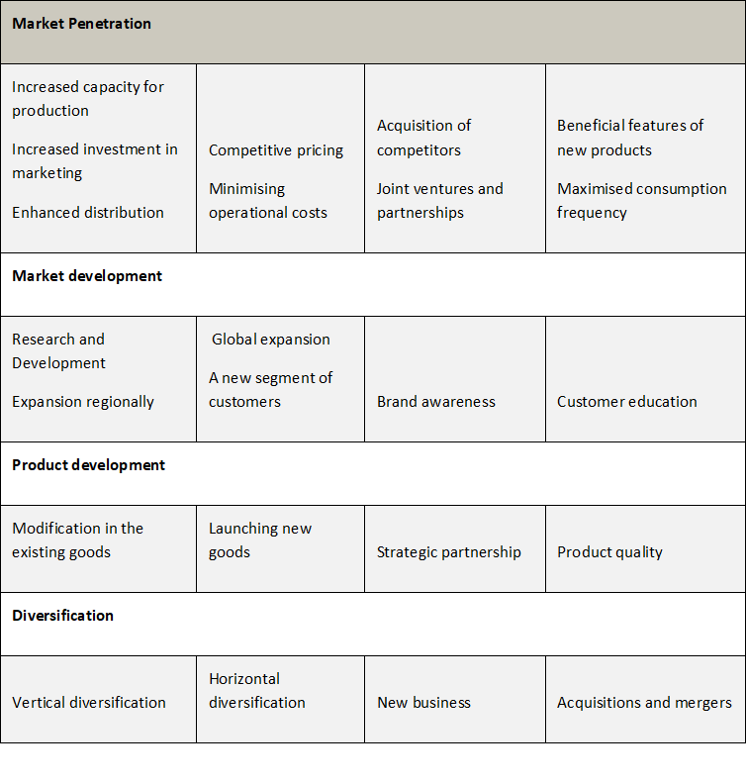
Figure 04: Ansoff Matrix of AstraZeneca (Kukartsev et al., 2019)
In this manner AstraZeneca maintained market leadership and growth in the changing pharmaceutical industry by using these techniques.

Suitable Market Entry Strategy or Criteria- Strategic Alliance
The SWOT analysis and Ansoff Matrix revealed that a market entry criterion of this organisation regional and worldwide expansion is best suitable for the company's global growth, as the insights from this marketing tools indicated that a strategic alliance is the most suitable market entry strategy for global expansion. AstraZeneca's assets included its worldwide presence and robust R&D capabilities AstraZeneca, 2024 under which strategic relationships would allow AstraZeneca to use the local market experience and regulatory expertise of its, reducing market entry risks He, Ghobadian and Gallear, 2021). Therefore the knowledge exchange via strategic alliances would elevate boosts innovation and product development while the SWOT analysis already demonstrated that AstraZeneca invested in R&D and innovates, which supported this strategy. Additionally addressing shortcomings like supply chain vulnerabilities and patent litigations is crucial for risk mitigation under which the strategic partnerships would optimise AstraZeneca's supply chain by using partners' logistical networks (Wu et al., 2020). Similarly on exemplary standpoint working with local pharmaceutical businesses in emerging areas would help in assuring continuous supply and distribution, lowering the danger of Cefotan shortages. In this manner Alliances could also help AstraZeneca in managing complicated patent and price laws, preserving its market reputation and finances.
Furthermore strategic collaborations enhanced market expansion and penetration, promoting growth and diversification under which AstraZeneca's agreement with Daiichi Sankyo displayed how partnerships elevate market reach and product accessibility. According to the Ansoff Matrix, AstraZeneca potentially target new client groups and tailor its goods to local demands by partnering with local enterprises in high-growth regions like China and India therefore alliances would also help AstraZeneca diversify into new therapeutic areas and product lines (Blablová, 2021). In this manner it is affirmed that strategic collaborations or alliances enabled AstraZeneca to utilise its strengths, capitalise on opportunities and reduce risks of entering new markets via flexible and cost-effective global expansion hence this strategy would sustains its growth and keep AstraZeneca competitive in the changing pharmaceutical sector.

Brand Management

Keller Brand Equity Model

Overview of Model
The Keller Brand Equity Model (CBBE) is a strategy framework for building, measuring and managing brand equity under which the pyramid represented; Brand Identity, Brand Meaning, Brand Response and Brand Resonance (Figure 05). In this manner the model's organised brand equity building is important as organisations would increase client loyalty, lower marketing expenses and gain a durable competitive advantage via a good customer connection by going through these stages (Kevser Çınar, 2020).

Application to AstraZeneca
The Keller Brand Equity Model (CBBE) provide a systematic approach to brand equity by studying customers' brand knowledge structure and applying this methodology to AstraZeneca reveals multiple crucial points:
- Brand Salience: AstraZeneca's worldwide presence and R&D investments elevated brand awareness hence its pharmacological name helped buyers remember the brand (AstraZeneca, 2024).
- Brand Performance: AstraZeneca's diverse pharmaceutical portfolio, including cancer, cardiovascular and respiratory medicines indicated quality as customers trust brands that deliver consistent product efficacy and regulatory compliance (M, 2020).

- Brand Image: Innovation and patient care enhanced the brand of the company while strategic alliances, ethical practices and community participation enhanced its healthcare solutions leadership (Ocloo et al., 2021).
- Brand Judgements: Customers trust and innovation at AstraZeneca developed good brand judgment because this proactive approach to global health issues like the COVID-19 vaccination elevates business brand and consumer esteem (Astrazeneca.com, 2021).
- Brand Feelings: AstraZeneca's life-saving drugs and patient-centric approach make customers happy and these feelings are heightened by successful marketing strategies that emphasised over the brand's health and wellness (Astrazeneca.com, 2021).
- Brand Resonance: Brand loyalty is seen in attitude and behaviour as quality, innovation, and loyalty programmes helped AstraZeneca retain consumers demonstrating brand resonance (Ocloo et al., 2021).
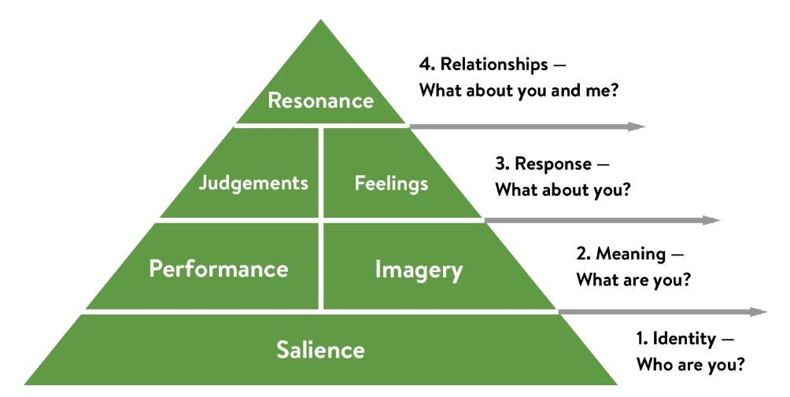
Figure 05: Keller’s Brand Equity Model (Hawker, 2019)
In this manner by following Keller's model, AstraZeneca maintained and grew its brand equity, assuring long-term competitive advantage and consumer loyalty.

Psychological and Sociological Factors Influencing Consumer Decision Making
Psychological and sociological factors strongly impact consumer decisions about health and medicine under which pharmaceutical businesses like AstraZeneca required to understand these impacts to modify their marketing efforts.

Psychological Factors
Perceived Risk: Health and medication decisions are influenced by consumers' risk perceptions as the Kaiser Family Foundation found that 67% of Americans worry about unexpected medical expenditures, which influenced their health decisions (Figure 06) (Rau and Rau, 2018). Additionally medication side effects, effectiveness and cost might constitute perceived risks while the brand reputation and professional guidance are relied on more in high-risk situations (Li et al., 2020).
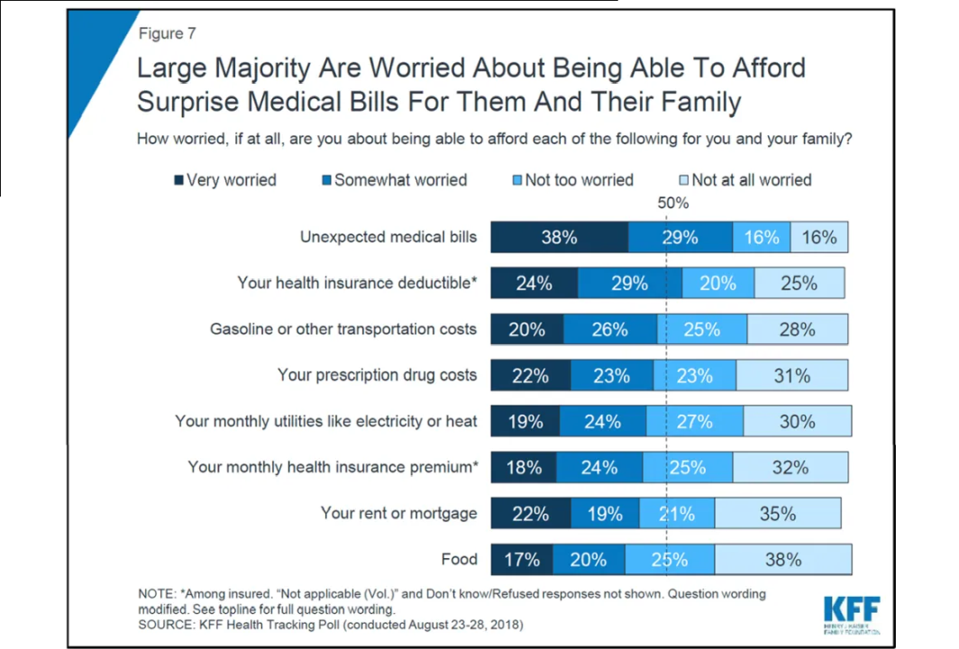
Figure 06: People Worry about Expenditure Risk (Rau and Rau, 2018)
Health Beliefs and Knowledge: The Health Belief Model (HBM) predicted health behaviours based on health beliefs, anticipated benefits of action and obstacles to action under which according to Karl et al. (2022), the population with high health literacy are more likely to take preventative health measures and take their prescriptions.

Sociological Factors
Social Influence: Family, peer and social networks strongly influenced health decisions as CDC (2024) indicated that social endorsement increased health service utilisation by 29% while social evidence like testimonials and word-of-mouth recommendations can drive customer behaviour.
Cultural Norms and Values: Culture influenced health and pharmaceutical utilisation as the traditional medicine is preferred in many Asian cultures over Western drugs. According to a WHO report, 80% of African and Asian populations utilise traditional medicine for basic care therefore understanding these cultural settings would help organisations like AstraZeneca to tailor its marketing techniques to local beliefs and customs (Oyebode et al., 2016).
Pharmaceutical organisations like AstraZeneca potentially improve health outcomes and brand loyalty by critically studying these psychological and sociological factors to create more tailored and successful marketing tactics that appeal with varied customer bases.

Branding Strategy for AstraZeneca
To enter new markets and boost brand equity AstraZeneca required a comprehensive branding strategy that incorporates psychological and sociological consumer decision-making factors;
Address Perceived Risk: AstraZeneca should prioritise transparency regarding pharmaceutical efficacy and safety due to the significant perceived risk in health decisions as trust is built by making clinical trial and side effect information available followed by promoting healthcare professional endorsements to reduce risk (Varga, Spehar and Skirbekk, 2023).
Utilise Social Influence and Cultural Norms: AstraZeneca need to boost health service utilisation by partnering with local influencers and healthcare professionals as the market communications must be tailored to reflect cultural norms and beliefs, especially in traditional medicine settings (Varga, Spehar and Skirbekk, 2023)..
Enhance Brand Image and Encourage Brand Loyalty Programs: AstraZeneca should promote ethical behaviours and community health activities to strengthen brand linkages because highlighting successful interventions like the COVID-19 vaccine development would enhance the company's healthcare innovation reputation. Similarly rewarding repeat purchases will also improve both attitudinal and behavioural loyalty because these programmes emphasised over personalised experiences and rewards as loyal consumers save marketing expenses and generate reliable revenue (Mensah, Oppong and Addae, 2022).

Predicted Responses and Conversion Rate
AstraZeneca potentially boost customer trust and brand loyalty with this branding strategy because targeted awareness and endorsements would increase initial engagement by 20%. Similarly as consumers feel more educated and connected to the business, transparency and localised marketing would raise conversion rates by 15% while the customer retention potentially increased by 10% with loyalty programmes, assuring market growth. Collectively the suggested branding strategy possessed the potential to help AstraZeneca traversing new markets, building long-term customer connections followed by enhancement of brand equity.

New Product Development

Evaluation of Strengths and Weaknesses in Product Development

Strengths
- Extensive Collaboration and Global Network: The worldwide network and partnership with over 20 supplier partners in 15 countries enabled quick production scaling and a broad reach (Lovisa Håkansson, 2023).
- Effective Quality Control Measures: Integrating quality control measures throughout the production process is a key strength as the each batch went through over 60 tests to guarantee vaccination safety, purity and effectiveness while the PCR and HPLC are used in this stringent QC framework to ensure high standards and regulatory compliance throughout manufacturing (PMLiVE, 2023).
- Optimized and Scalable Manufacturing Processes: The creation of a scalable and optimised Chemistry, Manufacturing and Controls (CMC) method enabled high vaccination yields and consistency because for large-scale biopharmaceutical production, single-use bioreactors and membrane chromatography improve efficiency and reduce contamination (Astrazeneca.com, 2021).

Weaknesses
- Complex Supply Chain Management: Managing a complex global supply chain is referred as strength and a problem in terms of logistics and coordination because managing and synchronising various international partners can cause delays in the approval and testing of the new product, affecting production and distribution (Astrazeneca.com, 2021).
- Dependency on External Partners: The utilisation of the external partners for manufacturing and testing of the new products led to quality control concerns, production standard deviations and technology transfer delays (Lovisa Håkansson, 2023).
- Regulatory and Stability Challenges: Maintaining regulatory compliance and optimal stability throughout storage and transit is a complicated and time-consuming task while the stability testing alongside production of the new product would delay or change the manufacturing process if negative (PMLiVE, 2023).

International Marketing Strategy for Expansion
A comprehensive international marketing strategy centred on global branding, localised marketing, strategic partnerships and advanced digital marketing should be adopted by AstraZeneca to capitalise on its strengths and minimise shortcomings in new product development and international marketplace expansion;

Global Branding and Positioning
AstraZeneca's vast collaborative network and comprehensive quality control methods supported its position as a pharmaceutical innovation and dependability leader under which AstraZeneca can gain credibility in new international markets by emphasising these traits in its branding. In compliance highlighting strong testing methods and high standards in marketing would elevate brand equity by enhancing quality and brand connotations (Górska-Warsewicz, 2020).

Localised Marketing and Customisation
Acquisition of international market share required understanding and responding to local customs (Chan, 2024) as in traditional medicine-dominated regions, AstraZeneca should customise its marketing messaging to regional beliefs and practices because this strategy will tackle cultural elements' sociological impact on consumer behaviour.

Strategic Alliances
Cooperating with local pharmaceutical businesses, governments and healthcare organisations ease new market entrance and distribution because these relationships assist in managing regulations, meet local requirements and improve supply chain efficiency (He, Ghobadian and Gallear, 2021). In line to this building more integrated collaborations can reduce AstraZeneca's dependence on external partners, enhancing relationship marketing to develop long-term and mutually beneficial partnerships.

Advanced Digital Marketing and Data Analytics
AstraZeneca required adopting digital marketing and data analytics to forecast customer preferences in varied regions because this method would boost targeted marketing, customer interaction and resource allocation (Saura, 2021).

International Marketing Plan for Diprifusor’s Automated Drug Identification System
AstraZeneca requested an automated medication identification system for their Diprifusor target controlled infusion (TCI) system while to confirm that Diprivan was used and distinguish between the two medication concentrations, accurate drug identification was essential followed by and international marketing plan.
Marketing Plan
Objective | Introduce AstraZeneca's PMR-based automated medication identification system for Diprifusor in important international markets.
Milestone | Actions Required | Responsible Business Area | Timescale
Market Research and Analysis | 1. Conduct thorough market study in chosen regions (e.g., Europe, Asia, North America) to comprehend regulations, market demands, and competition.  2. Find suitable healthcare institutions and partners for early pilot testing and feedback. | Market Research Team | 1-3 Months
Regulatory Approvals and Compliance | 3. Obtain certifications and ensure PMR system compliance with local medical device standards.  4. Work with local officials to speed up approvals. | Regulatory Affairs Team | 4-6 Months
Strategic Partnerships and Alliances | 5. Partner with local hospitals, clinics, and healthcare professionals to trial the PMR system.  6. Partnerships with local distributors and medical equipment businesses enable market entrance and distribution. | Business Development Team | 7-9 Months
Localization and Customization | 7. Tailor marketing and product features to local cultural and linguistic needs.  8. Educate local partners and healthcare experts on PMR system usage and advantages. | Marketing and Product Development Teams | 7-12 Months
Digital Marketing Campaign and Launch | 9. Create a digital marketing plan including social media, online forums, and targeted ads to increase product awareness.  10. Conduct localised advertisements emphasising PMR system accuracy, safety, and innovation. | Digital Marketing Team | 10-15 Months
Post-Launch Monitoring and Support | 11. Track system performance and get early adopter input for improvements.  12. Train and assist healthcare providers and partners to maximise utilisation and customer satisfaction. | Customer Support and Sales Teams | 16-24 Months

Conclusion and Recommendations
This marketing report affirmed that for international market selection and entrance strategies, AstraZeneca can use marketing theories like the Product Life Cycle (PLC) and the Keller’s Equity Model to assess market growth and maturity. Additionally the SWOT analysis and the Ansoff Matrix displayed the strengths, weaknesses, opportunities and threats and offer market penetration and development options as the SWOT evaluated internal and external elements, while the Ansoff Matrix relate strategic alternatives to growth goals. Moreover the report indicated that AstraZeneca's strengths are R&D, worldwide presence and varied pharmaceutical portfolio however poor supply chain management, product discontinuations and patent litigations are weaknesses but rising healthcare demanded in emerging regions presented opportunities for the international marketplace expansions.

Recommendations
- Market Entry Strategic Alliances: Strategic partnerships with local pharmaceutical and healthcare firms in emerging regions can help AstraZeneca improve its deficiencies.
- Localised Marketing and Customization: Building trust and brand equity with local influencers and healthcare professionals helps boost AstraZeneca product uptake.
- Increase Digital Marketing and Data Analytics: Invest in advanced digital marketing and data analytics to forecast client preferences across geographies.
In this manner it is affirmed that AstraZeneca potentially enter new international markets, preserve competitive edge and develop sustainably by following these recommendations based on critical analysis.

References
‌ Astrazeneca.com. (2021). Innovating Production and Manufacture to meet the Challenge of COVID-19. [online] Available at: https://www.astrazeneca.com/what-science-can-do/topics/technologies/innovating-production-and-manufacture-to-meet-the-challenge-of-covid-19.html [Accessed 22 May 2024].
Akter, S., Hossain, M.A., Lu, Q.(S). and Shams, S.M.R. (2021), "Big data-driven strategic orientation in international marketing", International Marketing Review, Vol. 38 No. 5, pp. 927-947. https://doi.org/10.1108/IMR-11-2020-0256
Alexion Pharmaceuticals, Inc. (2023). Alexion, AstraZeneca Rare Disease, enters agreement with Pfizer to acquire a portfolio of preclinical rare disease gene therapies | Alexion Pharmaceuticals, Inc. [online] Available at: https://media.alexion.com/news-releases/news-release-details/alexion-astrazeneca-rare-disease-enters-agreement-pfizer-acquire [Accessed 22 May 2024].
‌Amri,. And Sami. (2022). Corporate Social Responsibility is NOT an Option is an Investment: A Study of AstraZeneca. International Journal of Asian Management. 8. 45-52.
Andreea Isabela Varga, Spehar, I. and Helge Skirbekk (2023). Trustworthy management in hospital settings: a systematic review. BMC health services research, [online] 23(1). doi:https://doi.org/10.1186/s12913-023-09610-5.
Ashp.org. (2016). Drug Shortage Detail: Cefotetan Disodium Injection. [online] Available at: https://www.ashp.org/drug-shortages/current-shortages/drug-shortage-detail.aspx?id=670&loginreturnUrl=SSOCheckOnly [Accessed 22 May 2024].
AstraZeneca | Company Overview & News. (2024). Forbes. [online] Available at: https://www.forbes.com/companies/astrazeneca/?sh=4befd3a76866 [Accessed 21 May 2024].
Astrazeneca.com. (2021). Digital health: Transforming how we develop medicines. [online] Available at: https://www.astrazeneca.com/r-d/digital-health-revolutionising-healthcare-for-patients.html [Accessed 21 May 2024].
Astrazeneca.com. (2021). Innovating Production and Manufacture to meet the Challenge of COVID-19. [online] Available at: https://www.astrazeneca.com/what-science-can-do/topics/technologies/innovating-production-and-manufacture-to-meet-the-challenge-of-covid-19.html [Accessed 23 May 2024].
Blablová, V. (2021). How China and India are Competing in Vaccine Diplomacy – chinaobservers. [online] chinaobservers. Available at: https://chinaobservers.eu/how-china-and-india-are-competing-in-vaccine-diplomacy/ [Accessed 22 May 2024].
CDC, (2024). Social Determinants of Health and Alzheimer’s Disease and Related Dementias. [online] Available at: https://www.cdc.gov/aging/disparities/social-determinants-alzheimers.html [Accessed 22 May 2024].
Chan, K. (2024). Commercialising everyday distress: neurasthenia and traditional Chinese medicine in colonial Hong Kong, 1950s to 1980s. Medical history, [online] pp.1–16. doi:https://doi.org/10.1017/mdh.2024.7.
Clifford, C. (2021). How the Moderna Covid-19 mRNA vaccine was made so quickly. [online] CNBC. Available at: https://www.cnbc.com/2021/07/03/how-moderna-made-its-mrna-covid-vaccine-so-quickly-noubar-afeyan.html [Accessed 21 May 2024].
Cristina, M. (2020). Family Firms and the Choice Between Wholly Owned Subsidiaries and Joint Ventures: A Transaction Costs Perspective - Maria Cristina Sestu, Antonio Majocchi, 2020. [online] Entrepreneurship Theory and Practice. Available at: https://journals.sagepub.com/doi/abs/10.1177/1042258718797925 [Accessed 21 May 2024].
Daiichisankyo.com. (2019). Daiichi Sankyo and AstraZeneca Announce Global Development and Commercialization Collaboration for Daiichi Sankyo’s HER2 Targeting Antibody Drug Conjugate [Fam-] Trastuzumab Deruxtecan (DS-8201) - Press Releases - Media - Daiichi Sankyo. [online] Available at: https://www.daiichisankyo.com/media/press_release/detail/index_3199.html [Accessed 21 May 2024].
Eric (2018). ASTRAZENECA Case Study Solution for Harvard HBR Case Study. [online] Caseism. Available at: https://caseism.com/astrazeneca-122070 [Accessed 22 May 2024].
Gilead.com. (2017). Kite Pharma and Fosun Pharma Establish Joint Venture in China to Develop and Commercialize Autologous T-Cell Therapies to Treat Cancer. [online] Available at: https://www.gilead.com/news-and-press/press-room/press-releases/2017/1/kite-pharma-and-fosun-pharma-establish-joint-venture-in-china-to-develop-and-commercialize-autologous-t-cell-therapies-to-treat-cancer [Accessed 21 May 2024].
Górska-Warsewicz, H. (2020). Factors Determining City Brand Equity—A Systematic Literature Review. Sustainability, [online] 12(19), pp.7858–7858. doi:https://doi.org/10.3390/su12197858.
Hantec Markets. (2023). Top-10 Biggest UK-based Companies 2023 | Hantec Markets. [online] Available at: https://hmarkets.com/top-10-uk-largest-companies/#az [Accessed 21 May 2024].
Hawker, K. (2019). Keller’s Brand Equity Model — What It Is & How to Use It. [online] Medium. Available at: https://medium.com/@keatonhawker/kellers-brand-equity-model-what-it-is-how-to-use-it-84e42d562299 [Accessed 22 May 2024].
He, Q., Ghobadian, A. and Gallear, D. (2021). Inter‐Firm Knowledge Transfer between Strategic Alliance Partners: A Way Forward. European management review, [online] 18(3), pp.229–248. doi:https://doi.org/10.1111/emre.12447.
Hussam Al Halbusi, Klobas, J.E. and T. Ramayah (2022). Green core competence and firm performance in a post‐conflict country, Iraq. Business strategy and the environment, [online] 32(6), pp.2702–2714. doi:https://doi.org/10.1002/bse.3265.
Jose Ramon Saura (2021). Using Data Sciences in Digital Marketing: Framework, methods, and performance metrics. Journal of innovation & knowledge/Journal of innovation and knowledge, [online] 6(2), pp.92–102. doi:https://doi.org/10.1016/j.jik.2020.08.001.
Karl, J., Fischer, R., Druica, E., Musso, F. and Cosma, A. (2022). Testing the Effectiveness of the Health Belief Model in Predicting Preventive Behavior During the COVID-19 Pandemic: The Case of Romania and Italy. Frontiers in psychology, [online] 12. doi:https://doi.org/10.3389/fpsyg.2021.627575.
Kevser Çınar (2020). Customer Based Brand Equity Models in Hotel Industry: A Literature Review. Springer proceedings in business and economics, [online] pp.281–288. doi:https://doi.org/10.1007/978-3-030-36126-6_31.
Koen Byttebier (2022). Covid-19 Vaccines and Medicines. Economic and financial law & policy - shifting insights & values, [online] pp.859–1029. doi:https://doi.org/10.1007/978-3-030-92901-5_9.
Kukartsev, V.V., Fedorova, N.V., Vadim Sergeevich Tynchenko and Boyko, A.A. (2019). The analysis of methods for developing the marketing strategies in agribusiness. [online] ResearchGate. Available at: https://www.researchgate.net/publication/335366665_The_analysis_of_methods_for_developing_the_marketing_strategies_in_agribusiness [Accessed 22 May 2024].
Li, Z., Sha, Y., Song, X., Yang, K., ZHao, K., Jiang, Z. and Zhang, Q. (2020), "Impact of risk perception on customer purchase behavior: a meta-analysis", Journal of Business & Industrial Marketing, Vol. 35 No. 1, pp. 76-96. https://doi.org/10.1108/JBIM-12-2018-0381
Liu, A. (2020). AstraZeneca snaps up Alexion for $39B in a leap toward CEO’s $40B revenue goal. [online] Fierce Pharma. Available at: https://www.fiercepharma.com/pharma/astrazeneca-pushes-closer-to-ceo-s-40b-revenue-goal-39b-alexion-acquisition [Accessed 21 May 2024].
Liu, A. (2022). AstraZeneca escapes one Seroquel pay-for-delay claim but loses bid to scrap another. [online] Fierce Pharma. Available at: https://www.fiercepharma.com/pharma/astrazeneca-escapes-one-seroquel-pay-delay-claim-loses-bid-scrap-another [Accessed 22 May 2024].
Lovisa Håkansson (2023). Pharmaceutical development in focus as AstraZeneca visits WACQT. [online] Chalmers.se. Available at: https://www.chalmers.se/en/current/news/mc2-pharmaceutical-development-in-focus-as-astrazeneca-visits-wacqt/ [Accessed 23 May 2024].
M. (2020). Regulatory approval of COVID-19 Vaccine AstraZeneca. [online] GOV.UK. Available at: https://www.gov.uk/government/publications/regulatory-approval-of-covid-19-vaccine-astrazeneca#:~:text=Also%20changed%20the%20name%20of,to%20the%20brand%20name%20%2D%20Vaxzevria. [Accessed 21 May 2024].
Macrotrends.net. (2024). AstraZeneca Revenue 2010-2024 | AZN. [online] Available at: https://www.macrotrends.net/stocks/charts/AZN/astrazeneca/revenue [Accessed 21 May 2024].
Mensah, J., Peter Kwasi Oppong and Addae, M. (2022). Effect of Packaging on Perceived Quality and Brand Loyalty: The Mediating Role of Brand Association in Over-the-Counter Market. Open journal of business and management, [online] 10(01), pp.297–313. doi:https://doi.org/10.4236/ojbm.2022.101018.
None Qui Lin, Xiaoyu, L. and Zhu Jianqiang (2023). The Apple Company’s Foreign Expansion and Market Entry Strategy. International Journal on Recent Trends in Business and Tourism, [online] 07(03), pp.47–60. doi:https://doi.org/10.31674/ijrtbt.2021.v07i03.004.
Ocloo, J., Garfield, S., Bryony Dean Franklin and Dawson, S. (2021). Exploring the theory, barriers and enablers for patient and public involvement across health, social care and patient safety: a systematic review of reviews. Health research policy and systems, [online] 19(1). doi:https://doi.org/10.1186/s12961-020-00644-3.
Oyinlola Oyebode, Ngianga-Bakwin Kandala, Chilton, P.J. and Lilford, R.J. (2016). Use of traditional medicine in middle-income countries: a WHO-SAGE study. Health policy and planning, [online] 31(8), pp.984–991. doi:https://doi.org/10.1093/heapol/czw022.
PEX Network (2023). AstraZeneca’s prescription for digital adoption success | Process Excellence Network. [online] Process Excellence Network. Available at: https://www.processexcellencenetwork.com/organizational-change/articles/astrazeneca-change-management-digital [Accessed 21 May 2024].
Pfizer.com. (2015). Pfizer Completes Acquisition of Hospira | Pfizer. [online] Available at: https://www.pfizer.com/news/press-release/press-release-detail/pfizer-completes-acquisition-hospira [Accessed 21 May 2024].
PMLiVE. (2023). AstraZeneca announces launch of new healthtech business Evinova to optimise clinical trials - PMLiVE. [online] Available at: https://pmlive.com/pharma_news/astrazeneca_announces_launch_of_new_healthtech_business_evinova_1504042/ [Accessed 23 May 2024].
Rau, J. and Rau, J. (2018). Surprise Medical Bills Are What Americans Fear Most In Paying For Health Care - KFF Health News. [online] KFF Health News. Available at: https://kffhealthnews.org/news/surprise-medical-bills-are-what-americans-fear-most-in-paying-for-health-care/ [Accessed 22 May 2024].
Raut, U.R., Pawar, P.A., Brito, P.Q. and Sisodia, G.S. (2019), "Mediating model of brand equity and its application", Spanish Journal of Marketing - ESIC, Vol. 23 No. 2, pp. 295-318. https://doi.org/10.1108/SJME-04-2019-0021
Reporter, A. (2023). Asthma Malaysia and AstraZeneca celebrates World Asthma Day, raised awareness on asthma management | News Hub Asia. [online] News Hub Asia. Available at: https://www.newshubasia.com/living/asthma-malaysia-and-astrazeneca-celebrates-world-asthma-day-raised-awareness-on-asthma-management/ [Accessed 21 May 2024].
Sagentia Innovation | Technology advisory and product development consultants. (2006). Sagentia Innovation. [online] Available at: https://www.sagentiainnovation.com/case-studies/astrazeneca-innovation-in-medical-product-development/ [Accessed 23 May 2024].
Schlegelmilch, B.B. (2022). Global Marketing Strategy. SpringerLink. [online] doi:https://doi.org/10.1007-978-3-030-90665-8.
Tarcza Teodora, Popa, A. and Nemteanu Marcela Sefora (2018). Marketing Topics Related to General Data Protection Regulation (GDPR) in Europe in an Online Environment. [online] ResearchGate. Available at: https://www.researchgate.net/publication/341600474_Marketing_Topics_Related_to_General_Data_Protection_Regulation_GDPR_in_Europe_in_an_Online_Environment [Accessed 21 May 2024].
Team TBH (2024). Marketing Strategy and Marketing Mix of AstraZeneca. [online] The Brand Hopper. Available at: https://thebrandhopper.com/2024/02/25/marketing-strategy-and-marketing-mix-of-astrazeneca/ [Accessed 21 May 2024].
Thais González-Torres, José-Luis Rodríguez-Sánchez, Pelechano-Barahona, E. and García-Muiña, F.E. (2020). A Systematic Review of Research on Sustainability in Mergers and Acquisitions. Sustainability, [online] 12(2), pp.513–513. doi:https://doi.org/10.3390/su12020513.
Verma, K. (2024). What a string of semaglutide biosimilars could mean for Mainland China - Clarivate. [online] Clarivate. Available at: https://clarivate.com/blog/what-a-string-of-semaglutide-biosimilars-could-mean-for-mainland-china/ [Accessed 21 May 2024].
Wu, C., Zhang, Y., Pun, H. and Lin, C. (2020). Construction of partner selection criteria in sustainable supply chains: A systematic optimization model. Expert systems with applications, [online] 158, pp.113643–113643. doi:https://doi.org/10.1016/j.eswa.2020.113643.
Zanjani, S., Soleyman Iranzadeh, Asadollah Khadivi and Naser Feghhi Farahmand (2020). Designing a Corporate Growth Strategy Based on Ansoff Matrix Using Fuzzy Inference System. [online] 3(2), pp.151–178. doi:https://doi.org/10.22034/qjimdo.2020.211344.1236.

