Social networking sites usage among university students. A cross sectional study
[Name of Student]
[Name of Institute]

Abstract
The current investigation sheds light on the prevalence of social media consumption by university students in Malaysia. With quantitative cross-sectional studies, the impact of its usage has been determined by including a sample of 237 participants. The investigator collected participants' responses through the primary data collection technique by using a close-ended questionnaire survey approach. The emphasis while inspecting is to explore which social media sites are mostly used and whether there exist any regulations while using them at home. Further investigation outlines an association between its increased usage by university students and health challenges raised among its users related to, i.e. sleeping disorders, mental depression, and anxiety. Results of the study denote negative health impacts among students with increased usage of social media sites. A decrease in academic performance and an adverse impact on health and well-being have been determined to be consequences of excessive consumption among students. Based on quantitative results, creating digital awareness and raising the significance of parental involvement are determined as substantial factors to consider.

Table of Contents
Social networking sites usage among university students. A cross sectional study 1
1 Abstract 2
2 Chapter:1 Introduction 3
3 Chapter:2 Literature review 4
3.1 Emergence of social network sites 4
3.2 Why Is Smartphone So Addictive? 5
3.2.1 Psychological factors 6
3.2.2 Sociological factors 6
3.2.3 Technological factors 7
4 Chapter:3 Methodology 7
5 Chapter:4 Findings and Results 8
5.1 Quantitative results 8
5.1.1 Demographic representation 8
5.2 Chi-square test 22
5.3 Discussion 24
5.3.1 Interpretation 24
5.3.2 Implications 27
5.3.3 Limitations 28
5.3.4 Recommendations 28
6 Conclusion 29
7 References 29

Chapter:1 Introduction
With increased online digital consumption, awareness and access to social media sites have been raised in the last decade. Social media channels are used as a medium to conveniently communicate globally. During pandemics, a major proportion of the population relies on social media sites to communicate with their associates, i.e. family, friends, etc. (Juvonen et al., 2021). With increased knowledge, people have been widely using this application on a daily basis. While being advantageous, in contrast, it has several challenges for users due to i.e. excessive consumption, over-dependence, etc., with convenient access through smartphones, children have been majorly identified in using social media sites (Abbasi and Huang., 2020).
With increased addiction, students at different educational levels are centred on mental distress. According to a survey report, nearly 90% of teenagers have been identified as consuming social media applications (Bozzola et al., 2022). Academic scholars argued that the prevalence of earlier age availability to smartphones has been a primary factor contributing to making young children addicted to social media sites with increased daily consumption for students.
It has become the primary responsibility of educational institutions, the healthcare sector, policymakers, etc., to seek drawbacks associated with the excessive consumption of routine life patterns among university students. By inspecting the long-term consequences that its increased usage imposes on students, considerable policies need to be recommended.
The current investigation outlines valuable insights by conducting a cross-sectional study on university students in Malaysia and quantitatively analyzing their reviews. The study aims to explore an in-depth understanding of the prevalence of social networking site usage while identifying consumption rates on well-renowned digital channels to identify factors that lead to increased usage among students.
The consumption ratio of social media sites in Malaysia has increased in the last few years, as with increased recognition and awareness of digital online channels, these forums have been excessively used to fulfil individual priorities and accommodate varied choices. With the digital revolution, university students have become digitally aware of social media sites. Thence investigator based on the study makes readers knowledgeable about the extent of its consumption and its impact on students' health and well-being.

Chapter:2 Literature review

Emergence of social network sites
The ascent of social networking sites (SNS) has basically changed the location of correspondence, particularly among school students (Thelwall, 2009). This segment has embraced long-range interpersonal social networking sites (SNS) as fundamental devices for mingling, sharing data, and systems administration since they are advanced locals (Ryan et Al., 2011). Facebook, Instagram, and Twitter's rapid growth have brought about a new era of availability, affecting various aspects of college life (Arora et Al., 2019). For instructors, policymakers, and specialists endeavouring to explore the computerized age's intricacies, having an intensive comprehension of the points of interest of SNS use among college students is fundamental.
This composing overview gives a broad assessment of the utilisation models, impacts, and factors influencing long-reach casual correspondence objections among school students (Morgan and Winship, 2015). We anticipate providing insight into the complicated concept of SNS commitment in an academic setting by orchestrating existing research (Thelwall, 2009. Furthermore, this review hopes to recognise openings in the recurring pattern assortment of data, offering encounters that can coordinate future assessment endeavours and enlighten valuable interventions.
The degree of this study focuses for drove generally on school students and their responsibility with various long-reach relational correspondence stages. While the consideration is basically on academic repercussions, the review will, in like manner, research the greater signification and security-related parts of SNS usage (Dhiman, 2021). In perceiving the obstructions of this study, seeing the potential for social assortments in SNS use and its effects is basic. In addition, due to innovation's constant development, some discoveries may become obsolete or dependent on future developments (Arora et Al., 2019). Despite these limitations, the goal of this survey is to provide a robust and knowledgeable integration of existing writing on the subject (Ting, 2019). The significance of understanding this to contemporary advanced education is underscored in this presentation, which makes way for a thorough assessment of the utilization of person-to-personson-to-person communication destinations by college understudies (Flournoy, 2019).

Why Is Smartphone So Addictive?
In the advanced era, cell phones have turned into a fundamental piece of our day-to-day routines, forming the manner in which we impart, work, and engage ourselves (Swamy, 2020). However, concerns have been raised regarding the impact of smartphone addiction on mental health and wellbeing. This writing audit means to investigate the different elements adding to the habit-forming nature of cell phones, drawing experiences from mental, humanistic, and innovative points of view.

Psychological factors
1. Instant Gratification: Cell phones give instant admittance to data, correspondence, and diversion. The moment satisfaction related to these exercises sets off the arrival of dopamine, a synapse related to delight and prize (Volbedra et al., 2021). This neurological reaction builds up the way of behaving, adding to the habit-forming nature of cell phone use.
2. fear of missing out (FOMO): Virtual entertainment stages and steady warnings create a feeling of dread toward passing up get-togethers, news, or updates. People might feel a sense of urgency to check their cell phones consistently to remain associated, prompting a pattern of enthusiastic conduct driven by the requirement for social approval and a feeling of dread toward prohibition.
3. Escape Mechanism: Cell phones act as a helpful getaway from the real world. Whether through gaming, web-based entertainment, or real-time features, people might utilize cell phones as a way to stay away from pressure, weariness, or pessimistic feelings (Huang and Miao, 2021). Excessive use and dependence can result from this escapism, which encourages addictive behaviour.

Sociological factors
1. Social Influence: Peer pressure and cultural standards assume a critical part in cell phone dependence. The far and wide utilization of cell phones in groups of friends gives a feeling of having a place, and people might take part in extreme cell phone use to adjust to social assumptions (Dhiman, 2021). The longing to fit in and be acknowledged can drive habit-forming ways of behaving.
2. Social Comparison: Social media platforms make it easy to constantly compare oneself to other people, which can make people feel inadequate or make them feel the need to show a curated and idealized version of their life (Ting, 2019). This steady correlation encourages a serious outlook, driving people to invest more energy in their cell phones, looking for approval and endorsement.
3. Productivity at Work: The reconciliation of cell phones into proficient life obscures the limits of work and individual time. The consistent network of business-related errands and messages gives a feeling of responsibility to be accessible consistently. This business-related tension can add to cell phone fixation as people battle to withdraw.

Technological factors
1. Design Features: Cell phone applications and points of interaction are deliberately intended to be easy to use and lock in. The utilization of boundless looking over, pop-up messages and autoplay highlights improve client commitment yet additionally adds to the constant and impulsive utilization of cell phones (Bucci et al., 2019). These plan components exploit mental weaknesses, making the gadgets more habit-forming.
2. Gamification Elements: Numerous applications consolidate gamification components, like rewards, identifications, and focuses, to empower customary use (Dhiman, 2021). These highlights trigger pride and rivalry, animating the prize places in the mind. Clients might end up constrained to draw in with these applications more than once, adding to habit-forming conduct.
3. Personalization Algorithms: The utilization of calculations to customize content feeds and suggestions tailors cell phone insight to individual inclinations (Volbedra et al., 2021). In addition to increasing user satisfaction, this also creates a filter bubble that reinforces preexisting values and beliefs. The steady support of content that lines up with one's perspectives can prompt habitual use as people look for attestation and commonality.
The addictive nature of cell phones is a mind-boggling peculiarity impacted by a horde of mental, humanistic, and mechanical variables. The exchange between moment delight, social impacts, and configuration highlights makes a powerful coincidence that cultivates impulsive cell phone use 9Swamy, 2020). Perceiving these elements is urgent for creating viable mediations and systems to moderate cell phone fixation and advance a better relationship with these pervasive gadgets. Further examination is justified to investigate the drawn-out results of cell phone dependence and distinguish creative answers to address this developing cultural concern.

Chapter:3 Methodology
The current investigation makes use of a quantitative cross-sectional approach to collect participants' information for the study. With quantitative research, the design researcher will acknowledge readers pertaining to an in-depth evaluation of the topic considered. Additionally, primary data collection techniques have been used while inspecting the goals of the investigation. Responses were collected from participants with a closed-ended questionnaire. For collecting primary data, a sample size of 237 students who are studying at different Malaysian universities has been considered. Primary responses will be collected based on demographic factors, individual preferences for social media consumption, consumption patterns, impact on mental health, etc. To analyze the data set, SPSS software was used to quantitatively evaluate primary responses obtained from participants. Quantitative results to be included within the investigation oblige the investigator to make sustainable recommendations to policymakers in the educational and healthcare sectors.

Chapter:4 Findings and Results

Quantitative results
To analyze primary responses collected from 237 participants, data has been analyzed quantitatively by means of SPSS software by conducting frequency distribution tests and chi-square tests, respectively. Below is an outlined statistical representation pertaining to quantitative results obtained based on the generated questionnaire.

Demographic representation

Figure 1- Gender of the participants
Results obtained based on frequency distribution have been outlined in the above section. Below is the representation of statistical findings obtained through frequency distribution.
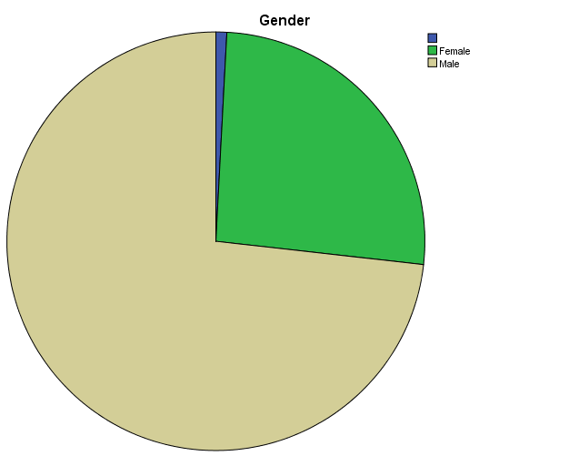
Based on frequency tests, an investigator conducted a demographic analysis that outlined an overview of participants. From 237 participants, 62 are female and 175 are male, who have been involved in the study.

Figure:2-Age of the respondents
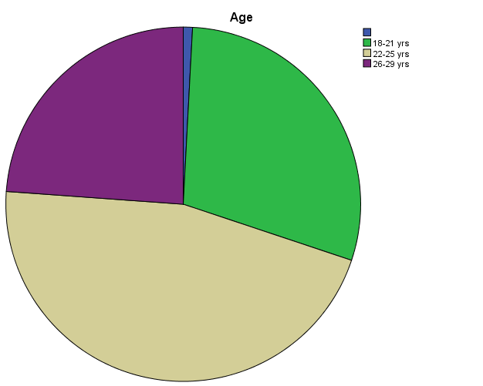
While categorized based on age factor, it is evident from the pie chart formation of the quantitative results that nearly 70 participants are categorized within the age group between 18 and 21 years. Additionally, nearly 110 participants are between the age groups 22 and 25. 57 respondents are lying within 26-9 years.

Figure:3- Ethnicity of the participants
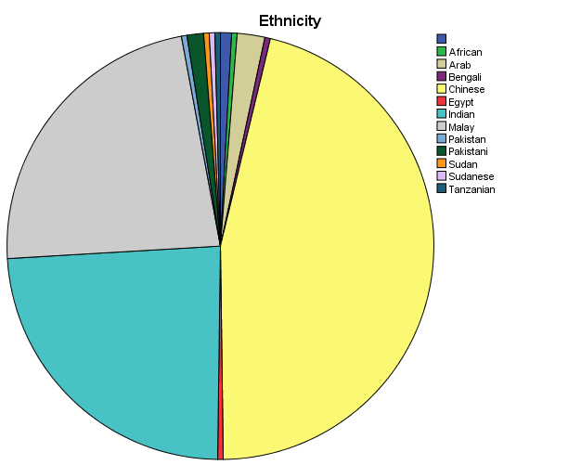

While categorizing based on ethnicity, pie chart formation outlined a graphical overview representing participants' ethnicity. The majority of participants, approximately 110, are from China, whereas 57 participants are from India and 55 from Malay.

Figure:4-Name of the Program enrolled

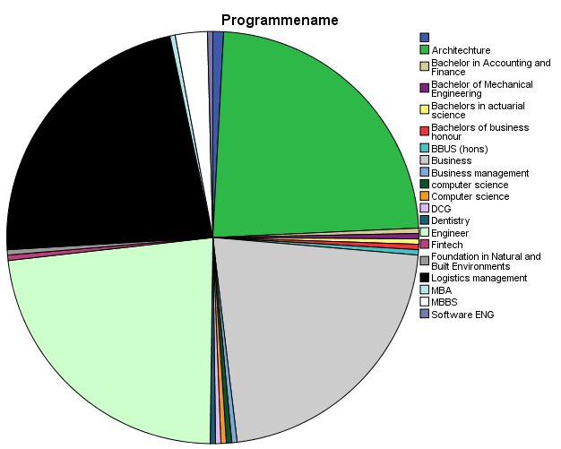
Students from various universities have been enrolled in different programs that are statically represented within the pie diagram shown in the results section.

Figure:5- Years of study

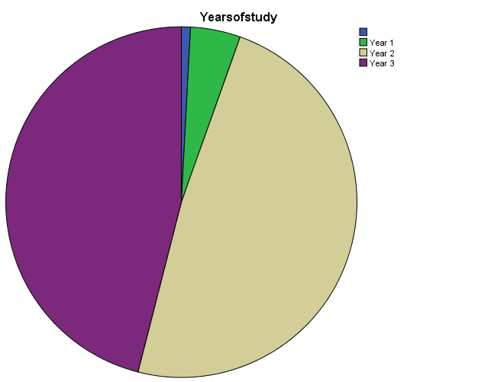
In addition, 11 respondents have been enrolled in 1st year, 116 participants are enrolled within 2nd year, and 110 participants are within 3rd year.

Table:1-Devices owned by participants
Whichofthefollowingdevicesdoyouown
 |  | Frequency | Percent | Valid Percent | Cumulative Percent
Valid |  | 2 | .8 | .8 | .8
Valid | Ipad/Tab | 54 | 22.6 | 22.6 | 23.4
Valid | Personal computer (PC) | 52 | 21.8 | 21.8 | 45.2
Valid | Personal computer (PC), Smart watch | 55 | 23.0 | 23.0 | 68.2
Valid | Smartphone | 1 | .4 | .4 | 68.6
Valid | Smartphone, Ipad/Tab, Smart watch | 3 | 1.3 | 1.3 | 69.9
Valid | Smartphone, Personal computer (PC) | 6 | 2.5 | 2.5 | 72.4
Valid | Smartphone, Personal computer (PC), Ipad/Tab | 5 | 2.1 | 2.1 | 74.5
Valid | Smartphone, Personal computer (PC), Ipad/Tab, Smart watch | 3 | 1.3 | 1.3 | 75.7
Valid | Smartphone, Personal computer (PC), Smart watch | 2 | .8 | .8 | 76.6
Valid | Smartphone, Smart watch | 56 | 23.4 | 23.4 | 100.0
Valid | Total | 239 | 100.0 | 100.0

When asked about devices owned by students, the majority of participants mentioned that they have iPads, personal computers, smart watches, etc., used for social media consumption.

Table:2-Devices owned by a family
Whichofthefollowingdevicesareownedbyyourfamily
 |  | Frequency | Percent | Valid Percent | Cumulative Percent
Valid |  | 2 | .8 | .8 | .8
Valid | Computer | 52 | 21.8 | 21.8 | 22.6
Valid | Smartphone | 1 | .4 | .4 | 23.0
Valid | Smartphone, Ipad/Tab | 54 | 22.6 | 22.6 | 45.6
Valid | Telvision | 1 | .4 | .4 | 46.0
Valid | Telvision, Computer | 55 | 23.0 | 23.0 | 69.0
Valid | Telvision, Ipad/Tab | 56 | 23.4 | 23.4 | 92.5
Valid | Telvision, Smartphone, Computer | 3 | 1.3 | 1.3 | 93.7
Valid | Telvision, Smartphone, Computer, Ipad/Tab | 13 | 5.4 | 5.4 | 99.2
Valid | Telvision, Smartphone, Ipad/Tab | 2 | .8 | .8 | 100.0
Valid | Total | 239 | 100.0 | 100.0

When asked about devices acquired by their family members, it is evident from participants' responses outlined within frequency distribution that family members of 56 of the students have televisions, iPads/Tablets, whereas 55 of the respondents have televisions and computers and vice versa.

Table:3-Devices used in a bedroom

Whichofthefollowingdevicesarethereinyourbedroom
 |  | Frequency | Percent | Valid Percent | Cumulative Percent
Valid |  | 2 | .8 | .8 | .8
Valid | Computer | 109 | 45.6 | 45.6 | 46.4
Valid | Smartphone | 112 | 46.9 | 46.9 | 93.3
Valid | Smartphone, Computer | 3 | 1.3 | 1.3 | 94.6
Valid | Smartphone, Computer, Ipad/Tab | 2 | .8 | .8 | 95.4
Valid | Smartphone, Ipad/Tab | 1 | .4 | .4 | 95.8
Valid | Telvision, Smartphone, Computer | 1 | .4 | .4 | 96.2
Valid | Telvision, Smartphone, Computer, Ipad/Tab | 8 | 3.3 | 3.3 | 99.6
Valid | Telvision, Smartphone, Ipad/Tab | 1 | .4 | .4 | 100.0
Valid | Total | 239 | 100.0 | 100.0

Further, while asked from participants about devices students have within their bedrooms, the majority of participants, i.e. 109 etc., mentioned computers, whereas 112 acknowledged that they have smartphones.

Table:4-Age of receiving device

Atwhatagedidyouhavetheownershipofyourfirstsmartphone
 |  | Frequency | Percent | Valid Percent | Cumulative Percent
Valid |  | 2 | .8 | .8 | .8
Valid | 12-14 years | 63 | 26.4 | 26.4 | 27.2
Valid | 15-17 years | 172 | 72.0 | 72.0 | 99.2
Valid | Less than 11 years old | 2 | .8 | .8 | 100.0
Valid | Total | 239 | 100.0 | 100.0

In addition, when asked about ownership of a phone, nearly 172 participants mentioned that they acquired smartphones between the ages of 15 and 17. Additionally, 63 participants demonstrated that they attained a smartphone between the ages of 12 and 14.

Table:5-How often do you use your social media

Howoftendoyouuseyoursocialmediaaccounts
 |  | Frequency | Percent | Valid Percent | Cumulative Percent
Valid |  | 2 | .8 | .8 | .8
Valid | Less than once a week | 110 | 46.0 | 46.0 | 46.9
Valid | Never | 1 | .4 | .4 | 47.3
Valid | Once a day or more | 73 | 30.5 | 30.5 | 77.8
Valid | Once a week or more | 53 | 22.2 | 22.2 | 100.0
Valid | Total | 239 | 100.0 | 100.0

On being asked about the probability of utilizing social media channels, 112 participants mentioned that they make use of digital applications once a week or more, and 61 participants outlined that they never used any recognized social media application. Additionally, 58 participants elaborated that they utilize social media accounts once a week or more.

Table:6-How often do you post on social media

Howoftendoyoupostinyoursocialmediaaccount
 |  | Frequency | Percent | Valid Percent | Cumulative Percent
Valid |  | 2 | .8 | .8 | .8
Valid | Less than once a week | 6 | 2.5 | 2.5 | 3.3
Valid | Never | 61 | 25.5 | 25.5 | 28.9
Valid | Once a day or more | 58 | 24.3 | 24.3 | 53.1
Valid | Once a week or more | 112 | 46.9 | 46.9 | 100.0
Valid | Total | 239 | 100.0 | 100.0

Frequency distribution results further demonstrate posts made by participants, as nearly 112 respondents mentioned that they post on various social media applications approximately once a week or more. Additionally, 61 participants outlined that they never posted on social media channels. Meanwhile, responses collected from 58 respondents indicate that they post once within a day or more.

Table:7-Preferred social media application

Yourpreferredsocialmedianetworks
 |  | Frequency | Percent | Valid Percent | Cumulative Percent
Valid |  | 2 | .8 | .8 | .8
Valid | Instagram | 67 | 28.0 | 28.0 | 28.9
Valid | Snapchat | 1 | .4 | .4 | 29.3
Valid | Twitter | 53 | 22.2 | 22.2 | 51.5
Valid | Whatsapp | 116 | 48.5 | 48.5 | 100.0
Valid | Total | 239 | 100.0 | 100.0

While identifying preferred social media applications for participants, 116 respondents mentioned WhatsApp applications. 67 responded to Instagram, whereas 53 respondents elaborated on Twitter.

Table:8-How many hours per day you spend on social media

Onaveragehowmanyhoursdoyouspendperdaysurfingsocialm
 |  | Frequency | Percent | Valid Percent | Cumulative Percent
Valid |  | 2 | .8 | .8 | .8
Valid | 1-2 hours | 55 | 23.0 | 23.0 | 23.8
Valid | 3-4 hours | 118 | 49.4 | 49.4 | 73.2
Valid | Less than an hour | 2 | .8 | .8 | 74.1
Valid | More than 4 hours | 62 | 25.9 | 25.9 | 100.0
Valid | Total | 239 | 100.0 | 100.0

To identify consumers' social media consumption rate on an average frequency, a response has been analyzed that outlines that 118 participants utilize these applications for 3-4 hours within a day. Additionally, 55 participants mentioned that they consumed for 1-2 hours, whereas 62 participants responded that they consumed for more than 4 hours.

Table:9-How many hours per day you spend on educational sites

Onaveragehowmanyhoursdoyouspendperdayaccessingeduca
 |  | Frequency | Percent | Valid Percent | Cumulative Percent
Valid |  | 2 | .8 | .8 | .8
Valid | 1-2 hours | 64 | 26.8 | 26.8 | 27.6
Valid | 3-4 hours | 110 | 46.0 | 46.0 | 73.6
Valid | Less than an hour | 63 | 26.4 | 26.4 | 100.0
Valid | Total | 239 | 100.0 | 100.0

Further, on being asked about the total consumption of educational sites within a day, 110 participants mentioned that they surf for educational material for about 3-4 hours. 64 of the participants stated that they consume 1-2 hours per day. In comparison, 63 participants stated that they spent less than an hour using educational websites while studying at home.

Table:10-How many hours per day you interact on social media sites

Onaveragehowmanyhoursdoyouspendperdayinteractingons
 |  | Frequency | Percent | Valid Percent | Cumulative Percent
Valid |  | 2 | .8 | .8 | .8
Valid | 1-2 hours | 115 | 48.1 | 48.1 | 49.0
Valid | Less than an hour | 121 | 50.6 | 50.6 | 99.6
Valid | More than 4 hours | 1 | .4 | .4 | 100.0
Valid | Total | 239 | 100.0 | 100.0

On being asked about the total hours being spent on social media channels each day while interacting on social media posts, 115 participants mentioned that they utilize 1-2 hours while commenting and responding to posts. 121 participants outlined that they utilize less than an hour and vice versa.

Table:11-How many hours perform exercise

Howoftendoyouexerciseinaweek
 |  | Frequency | Percent | Valid Percent | Cumulative Percent
Valid |  | 2 | .8 | .8 | .8
Valid | 1-2 times | 59 | 24.7 | 24.7 | 25.5
Valid | 3-4 times | 114 | 47.7 | 47.7 | 73.2
Valid | 5-7 times | 56 | 23.4 | 23.4 | 96.7
Valid | Never | 8 | 3.3 | 3.3 | 100.0
Valid | Total | 239 | 100.0 | 100.0

Additionally, while collecting responses about time spent performing physical exercise within a week, 114 participants mentioned that they spent 3-4 times each week. 59 respondents outlined using 1-2 times, whereas 56 participants mentioned that they consume 5-7 times each week.

Table:12-Do you feel sleepy during day time

Doyoufeelsleepyduringdaytimeduetoincreasedsocialmedia
 |  | Frequency | Percent | Valid Percent | Cumulative Percent
Valid |  | 2 | .8 | .8 | .8
Valid | No | 12 | 5.0 | 5.0 | 5.9
Valid | Yes | 225 | 94.1 | 94.1 | 100.0
Valid | Total | 239 | 100.0 | 100.0

When asked about whether they fall asleep during the day while excessively consuming social media applications at night, 225 participants responded that they fell asleep during the day, which demonstrates their excessive social media consumption at night. Additionally, 12 participants replied ‘no’, showing that this group of participants don’t consume social media applications or consume during the daytime.

Table:13-Do you get any depression due to social media

Didyougothroughanyformofdepressionduetosocialmediaus
 |  | Frequency | Percent | Valid Percent | Cumulative Percent
Valid |  | 2 | .8 | .8 | .8
Valid | No | 67 | 28.0 | 28.0 | 28.9
Valid | Yes | 170 | 71.1 | 71.1 | 100.0
Valid | Total | 239 | 100.0 | 100.0

When asked about any mental distress due to social media usage, i.e. depression, etc., 170 participants relied on ‘yes’, showing that due to excessive usage of well-renowned social media applications, people get depressed, whereas 67 responded ‘no’ respectively.

Table 14: Do you get any anxiety due to social media.

Didyougothroughanyformofanxietyduetosocialmediausage
 |  | Frequency | Percent | Valid Percent | Cumulative Percent
Valid |  | 2 | .8 | .8 | .8
Valid | No | 68 | 28.5 | 28.5 | 29.3
Valid | Yes | 169 | 70.7 | 70.7 | 100.0
Valid | Total | 239 | 100.0 | 100.0

Likewise, when asked about anxiety due to social media consumption, 169 participants replied ‘yes’, whereas 68 mentioned that they don’t feel any mental health challenges due to its excessive consumption.

Table 15: Awareness related to mental well-being.

Areyouawareofyourmentalwellbeingafterincreasedusageof
 |  | Frequency | Percent | Valid Percent | Cumulative Percent
Valid |  | 2 | .8 | .8 | .8
Valid | No | 168 | 70.3 | 70.3 | 71.1
Valid | Yes | 69 | 28.9 | 28.9 | 100.0
Valid | Total | 239 | 100.0 | 100.0

When asked about participants' mental well-being with excessive consumption of social media, 168 replied with ‘no’ whereas 69 answered with ‘yes’, showing that the majority of participants feel mental distress with its wide-scale consumption on a regular basis.

Table:16-Rules related to social media usage in homes

Regardingtheusageofsocialmediaarethereanyrulesinyour
 |  | Frequency | Percent | Valid Percent | Cumulative Percent
Valid |  | 2 | .8 | .8 | .8
Valid | No boundaries on usage or access | 71 | 29.7 | 29.7 | 30.5
Valid | Social media sites need permission | 110 | 46.0 | 46.0 | 76.6
Valid | Social medial access occasionally denied | 56 | 23.4 | 23.4 | 100.0
Valid | Total | 239 | 100.0 | 100.0

When asked about any regulations implied at participants' homes regarding the consumption of social media applications, 110 participants mentioned that they require authorization from their family members while consuming social media sites. Additionally, 71 participants outlined that there exist no restrictions on the consumption of social media sites. In addition, 56 participants mentioned that on an occasional basis, social media sites are denied.

Table:17-Relationship with parents on social media platforms

Howisyourrelationshipwithyourparentsonsocialmediaplatf
 |  | Frequency | Percent | Valid Percent | Cumulative Percent
Valid |  | 2 | .8 | .8 | .8
Valid | Always connected | 62 | 25.9 | 25.9 | 26.8
Valid | Never connected | 57 | 23.8 | 23.8 | 50.6
Valid | Occasionally connected | 118 | 49.4 | 49.4 | 100.0
Valid | Total | 239 | 100.0 | 100.0

Additionally, statistical results obtained through frequency distribution mention participants' responses to their communication with their parents on social media channels. 118 respondents mentioned that they occasionally connect with their parents, whereas 62 respondents always get connected with their parents and consume social media channels under their supervision. Meanwhile, 57 outlined that they never connected with their parents.

Chi-square test

Table 18- Checking for a relation between the age at which the smartphone was received and the of hours spent per day on social media

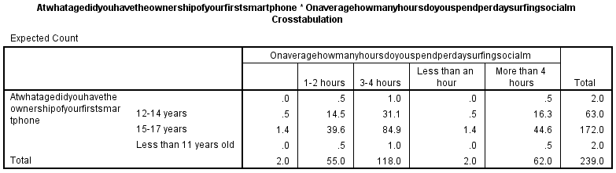
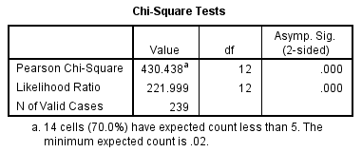

Table:19-Checking for a relation between the age at which smartphone was received and how often one uses social media

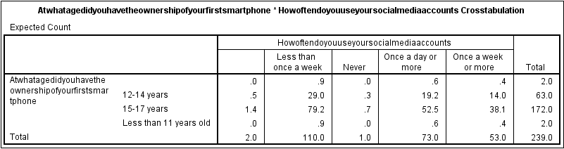
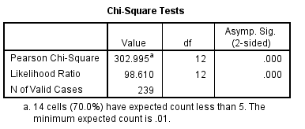

Table:20-Checking for a relationship between social media and depression
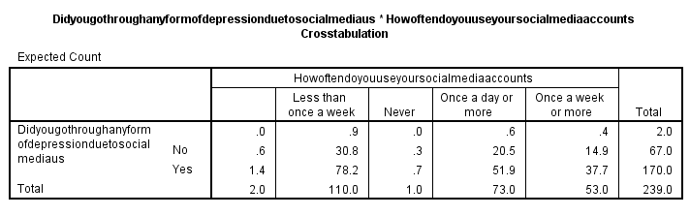
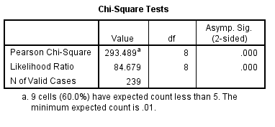

Table:21- Checking for a relationship between social media and anxiety
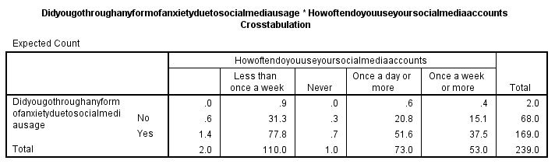
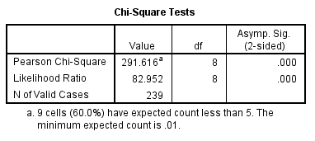

Discussion
Quantitative findings have been outlined in the above section of the study while identifying insights on the consumption of social media sites by university students. Based on frequency and chi-square tests, statistical values have been outlined in the investigation.

Interpretation

Adverse impact on sleep
Participants evidently mentioned that during the day, they fell asleep due to excessive social media consumption at night. With increased usage of social networking, students have been affected negatively as their sleeping times have been reduced. Sleeping disorder due to tiredness in the daytime potentially lowers physical strength and mental capabilities. Excessive consumption of social media applications is determined as a major cause behind their irregular sleeping patterns. To overcome psychological distress and to maintain mental health, maintaining appropriate sleeping duration is necessary for students. Maintaining quality time within studies while concentrating during class duration requires a proper and healthy sleeping pattern to be followed on a regular basis (Meltzer et al., 2021).

Mental burden and psychological distress
Sleep disorders lead to mental burdens and psychological illness among students. However, with proper sleeping duration, the ratio of anxiety and depression could potentially be reduced. Responses collected from participants outline that excessive consumption of social media applications has a negative impact on creating mental health challenges for students. Students at the university level have increased burdens of studies, and to maintain their career goals, they need to concentrate on their studies (Brooks et al., 2021). However, spending a larger proportion of their time on social media applications would adversely affect their studies.
To consistently perform by attaining good marks during class sessions requires a higher amount of mental well-being. With lower psychological distress, academic performance would be better. Over-dependence on social media applications and spending a higher amount of time using digital online applications, i.e. Instagram, etc., would have a negative influence on the well-being of students (Taylor., 2020).

Demographic differences in social media usage
A study by Kizgin et al.(2020) concludes that people from different ethnic backgrounds might have varied choices pertaining to their consumption of social media channels. People within developed countries are highly dependent on social media channels to spend most of their time. Regions in which convenient access is available for users, people residing in those countries majorly rely on social media consumption (Zhong et al., 2021). However, in underdeveloped countries with a lack of access to online digital platforms, people don’t have convenient availability to social media applications. Thence students' social media consumption rate can evidently be determined based on ethnic differences and sociodemographic factors.

Restrictions at homes
Primary responses obtained from participants evidently outline that parents are aware of children's excessive social media consumption, based on which parents have imposed limitations to restrict their children to avoid surfing disadvantageously. Emphasis has been placed on limited consumption rates by actively regulating their children's consumption to ensure restricted consumption. The rationale for restriction is to encourage children to spend the majority of their time on studies and healthier activities while avoiding using unethical content. University students belong to the age group in which there exists a probability that they adopt unethical life patterns; however, with sustained guidance, students would gain knowledge pertaining to the efficient consumption of social media sites.

Time spent on social media sites
Participants' responses collected through the questionnaire survey elaborate on a higher social media consumption rate for university students. It demonstrates that with increased usage of online digital channels, students emphasize spending a lower proportion of their regular daily routine while studying. It evidently indicates that higher social media consumption negatively impacts the educational performance of students. For academic improvement, there is a lower emphasis on social media sites, which are highly preferred by students (Lacka et al., 2021).

Time spent accessing education sites.
Further responses obtained from participants mentioned that students spend less time accessing educational sites. Convenient access to social media applications hinders students from focusing on studying for courses they are enrolled on. However, with a balanced routine lifestyle, students would improve their academic performance while emphasizing spending increased duration on educational sites.

Time spent in physical exercise
Responses collected indicate that students have a lower interest in spending their time in physical exercises due to increased access to social media sites. Students prefer to spend the majority of their time on social media channels, i.e., Instagram, Snapchat, etc., irrespective of performing sports activities. The findings of Shepherd et al.(2021) conclude that with athletic activities, students' physical and mental health develop. However, with increased social media consumption, mental distress and lack of social communication have been identified among students.

Implications

Educational performance for students
Increased consumption of social media sites would have an adverse impact on academic performance among students. University students enrolled in various courses are needed to adopt sustainable and balanced routines to deliver consistent educational productivity. It is evident that students who spend a higher proportion of their time in spending on social media channels encounter academic challenges. Sustainable academic performance has been a prerequisite to attaining good remarks. By spending balanced time, learners would improve their learning patterns.

Psychological health and well-being
The primary rationale for increased psychological distress among students has been due to the excessive social media consumption ratio; however, with timely health assistance and a balanced lifestyle, mental well-being would be improved. Consulting a psychological healthcare professional would be convenient to attain a well-adjusted routine schedule. Responses to the survey evidently outline lower mental well-being and increased psychological distress due to excessive social media usage.

Adoption of digital literacy
Timely guidance and appropriate education for children pertaining to secured social media consumption would improve their lifestyle. To make them aware of the psychological distress associated with its increased usage, the ratio of social media consumption would be minimized. By making students aware of threats associated with social media usage, i.e., bullying, harassment, data theft, etc., ethical boundaries would be imposed to improve sustainable outcomes.

Parental guidance
Parents perform a pivotal role in guiding and motivating their children towards sustainable consumption of social media sites. With consistent monitoring of children’s surfing behaviour, they are actively guided about risks associated with increased consumption of social media applications. With timely guidance, students are motivated to obtain healthier lifestyles while spending their time in ethical activities.

Limitations

Sample size
The current investigation has included a sufficient number of participants, i.e., 237 etc. However, due to unwillingness to further students, they haven’t been involved in the study. The researcher avoids the forceful involvement of students to raise the ratio of responses.

Self-collected data
Obtaining responses by relying entirely on students might lead to increased biasness within responses that would lower the scope of the study and restrict the researcher in attaining the objectives of the research.

Cross-sectional design
It has been a challenge for researchers to derive a sustainable causal relationship between social media consumption and its impact on students based on one-phased measurement and exposure to a limited area. Researchers emphasize analyzing students' social media usage behaviour within the Malaysian region; therefore, to obtain quality results through cross-sectional studies, other demographic regions are required to be explored.

Recommendations

Longitudinal studies
To evidently understand insights about the extent of the relationship between social media sites and their consumption by university students, future researchers are required to utilize longitudinal study patterns to attain causal and effective associations between social media consumption and its effect on students.

Increasing demographic groups
To gain a vast amount of knowledge, future researchers need to include a broader population by considering more demographic regions to attain an in-depth understanding of the consumption ratio among university students within other regions and how it has impacted their health and well-being.

Digital training by universities
Universities in Malaysia need to implement digital awareness initiatives by introducing training programs as a prerequisite necessity to make students aware of the sustainable consumption of social media sites to improve health and mental well-being.

Conclusion
The study outlines valuable knowledge pertaining to the consumption of social media sites among university students in Malaysia. The investigator included 237 participants from different universities in Malaysia to inspect the prevalence of consuming social media sites on their health and well-being. Quantitative findings of the investigation outline insights about associated factors with social media consumption, including, i.e. sleep disorder, increased depression/anxiety, etc. It is evident that with increased social media consumption, disruption within their sleeping duration would adversely affect their academic performance. Additionally, with decreased mental capabilities, decreased mental well-being has been identified among students. The results of the investigation provide detailed knowledge on the significance of creating awareness among students to improve their academic productivity and for preserving their health and well-being.

References
Abbasi, N.A. and Huang, D., 2020. Digital media literacy: Social media use for news consumption among teenagers in Pakistan. Global media journal, 18(35), pp.1-7.
Arora, A., Bansal, S., Kandpal, C., Aswani, R. and Dwivedi, Y., 2019. Measuring social media influencer index-insights from Facebook, Twitter and Instagram. Journal of retailing and consumer services, 49, pp.86-101.
Bozzola, E., Spina, G., Agostiniani, R., Barni, S., Russo, R., Scarpato, E., Di Mauro, A., Di Stefano, A.V., Caruso, C., Corsello, G. and Staiano, A., 2022. The use of social media in children and adolescents: Scoping review on the potential risks. International journal of environmental research and public health, 19(16), p.9960.
Brooks, R., Gupta, A., Jayadeva, S. and Abrahams, J., 2021. Students’ views about the purpose of higher education: a comparative analysis of six European countries. Higher Education Research & Development, 40(7), pp.1375-1388.
Bucci, S., Schwannauer, M. and Berry, N., 2019. The digital revolution and its impact on mental health care. Psychology and Psychotherapy: Theory, Research and Practice, 92(2), pp.277-297.
Dhiman, D.B., 2021. Impact of Smartphone: A Review on Negative Effects on Students. Abid Ali, B.(2021). Impact of Smartphone: A Review on Negative Effects on Students. PalArch's Journal of Archaeology of Egypt/Egyptology, 18(4), pp.5710-5718.
Flournoy, K., 2018. An Investigation of the Challenges Faced By Ghanaian International Students in the American Higher Education System: A Phenomenological Multi-Case Study (Doctoral dissertation, Roosevelt University).
Huang, Y. and Miao, W., 2021. Re-domesticating social media when it becomes disruptive: Evidence from China’s “super app” WeChat. Mobile Media & Communication, 9(2), pp.177-194.
Juvonen, J., Schacter, H.L. and Lessard, L.M., 2021. Connecting electronically with friends to cope with isolation during COVID-19 pandemic. Journal of Social and Personal Relationships, 38(6), pp.1782-1799.
Kizgin, H., Dey, B.L., Dwivedi, Y.K., Hughes, L., Jamal, A., Jones, P., Kronemann, B., Laroche, M., Peñaloza, L., Richard, M.O. and Rana, N.P., 2020. The impact of social media on consumer acculturation: Current challenges, opportunities, and an agenda for research and practice. International Journal of Information Management, 51, p.102026.
Lacka, E., Wong, T.C. and Haddoud, M.Y., 2021. Can digital technologies improve students' efficiency? Exploring the role of Virtual Learning Environment and Social Media use in Higher Education. Computers & Education, 163, p.104099.
Meltzer, L.J., Williamson, A.A. and Mindell, J.A., 2021. Pediatric sleep health: it matters, and so does how we define it. Sleep Medicine Reviews, 57, p.101425.
Morgan, S.L. and Winship, C., 2015. Counterfactuals and causal inference. Cambridge University Press.
Ryan, S.D., Magro, M.J. and Sharp, J.H., 2011. Exploring educational and cultural adaptation through social networking sites. Journal of Information Technology Education: Research, 10.
Shepherd, H.A., Evans, T., Gupta, S., McDonough, M.H., Doyle-Baker, P., Belton, K.L., Karmali, S., Pawer, S., Hadly, G., Pike, I. and Adams, S.A., 2021. The impact of COVID-19 on high school student-athlete experiences with physical activity, mental health, and social connection. International Journal of Environmental Research and Public Health, 18(7), p.3515.
Swamy, R.K., 2020. Mobiles have changed the way we communicate. International Journal of English Research, 6(6), pp.40-43.
Taylor, K.N., 2020. How does social media use impact students’ addiction, interpersonal skills, and well-being? (Doctoral dissertation, Northcentral University).
Thelwall, M., 2009. Social network sites: Users and uses. Advances in computers, 76, pp.19-73.
Ting, T.Y., 2019. East Asia in Action| Everyday Networked Activism in Hong Kong’s Umbrella Movement: Expanding on Contemporary Practice Theory to Understand Activist Digital Media Usages. International Journal of Communication, 13, p.20.
Volberda, H.W., Khanagha, S., Baden-Fuller, C., Mihalache, O.R. and Birkinshaw, J., 2021. Strategizing in a digital world: Overcoming cognitive barriers, reconfiguring routines and introducing new organizational forms. Long Range Planning, 54(5), p.102110.
Zhong, B., Huang, Y. and Liu, Q., 2021. Mental health toll from the coronavirus: Social media usage reveals Wuhan residents’ depression and secondary trauma in the COVID-19 outbreak. Computers in human behavior, 114, p.106524.

